Bracketed notes indicate where your own screenshots or measured results should be inserted after execution.
LAB IMPLEMENTATION EXPERIMENT 4
Variational Autoencoder (VAE) for Image Generation, Reconstruction and Latent Space Visualization
Generative AI Laboratory (CO1, CO2)
Aim
To implement a Variational Autoencoder using TensorFlow/Keras, reconstruct MNIST handwritten-digit images, generate new images by sampling latent vectors and visualize the learned two-dimensional latent space.
Theory
A Variational Autoencoder (VAE) is a generative neural network that learns a probability distribution for compact representations of input data. It contains an Encoder and a Decoder. The Encoder maps an input image to a latent distribution described by a mean vector (μ) and a log-variance vector (log σ²).
The Reparameterization Trick allows the network to sample a latent vector while preserving differentiability: z = μ + σ × ε, where ε is sampled from a standard normal distribution. The Decoder maps z back to an image that approximates the original input.
The VAE objective combines reconstruction loss and Kullback-Leibler (KL) divergence. Reconstruction loss measures the difference between the original and reconstructed image. KL divergence regularizes the learned latent distribution towards a standard normal distribution, which makes it possible to sample new points from the latent space.
Dataset note: the official experiment sheet specifies MNIST handwritten digits. The BattingCoach Roboflow dataset is an oriented object-detection dataset, not the prescribed digit dataset. MNIST is therefore used here to keep the VAE experiment aligned with the supplied lab instructions.
Steps
1. Install TensorFlow/Keras, NumPy, Matplotlib and Scikit-learn if latent-space plotting is required.
2. Load the MNIST training and test sets from tensorflow.keras.datasets.
3. Convert image values to floating point in the range 0 to 1 and reshape each 28×28 image into a 784-element vector.
4. Build the Encoder with dense layers that produce z_mean and z_log_var.
5. Implement a Sampling layer using the reparameterization formula z = μ + exp(0.5 × log_var) × ε.
6. Build the Decoder so that it maps the latent vector back to 784 output values with a sigmoid activation.
7. Define total loss as reconstruction loss plus KL divergence and train the VAE using the Adam optimizer.
8. Plot total, reconstruction and KL losses over training epochs.
9. Reconstruct a sample of test images and display each original image beside its reconstruction.
10. Sample random latent vectors, generate new digit images and visualize the two-dimensional latent representations of test samples.
Code
Core implementation excerpt (the complete runnable workflow is provided in the corresponding notebook).
%pip -q install tensorflow scikit-learn matplotlib
import tensorflow as tf, numpy as np, matplotlib.pyplot as plt
from tensorflow.keras import layers, Model
(x_train, y_train), (x_test, y_test) = tf.keras.datasets.mnist.load_data()
x_train = x_train.astype("float32").reshape(-1, 784) / 255.0
x_test = x_test.astype("float32").reshape(-1, 784) / 255.0
LATENT_DIM = 2
inp = layers.Input(shape=(784,))
h = layers.Dense(256, activation="relu")(inp)
h = layers.Dense(128, activation="relu")(h)
z_mean = layers.Dense(LATENT_DIM)(h)
z_log_var = layers.Dense(LATENT_DIM)(h)
class Sampling(layers.Layer):
def call(self, args):
mean, log_var = args
eps = tf.random.normal(tf.shape(mean))
return mean + tf.exp(0.5 * log_var) * eps
z = Sampling()([z_mean, z_log_var])
encoder = Model(inp, [z_mean, z_log_var, z])
z_in = layers.Input(shape=(LATENT_DIM,))
d = layers.Dense(128, activation="relu")(z_in)
d = layers.Dense(256, activation="relu")(d)
out = layers.Dense(784, activation="sigmoid")(d)
decoder = Model(z_in, out)
# Train using reconstruction loss + KL divergence.
# The complete custom train_step and 20-epoch fit are in the notebook.
# After training: compare originals/reconstructions and decode random z.
Output
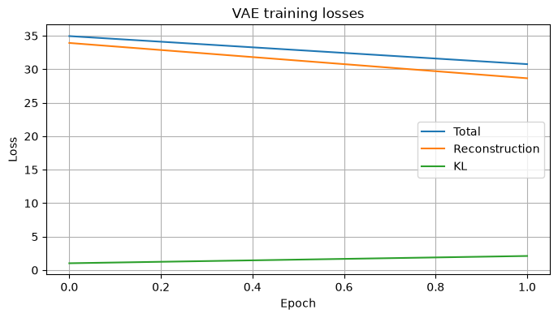

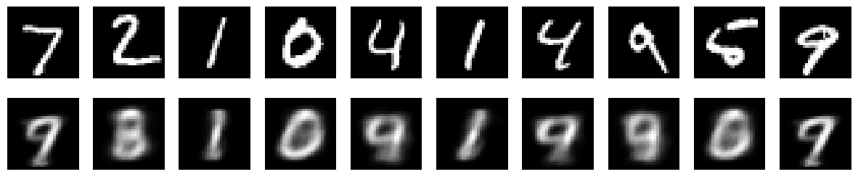
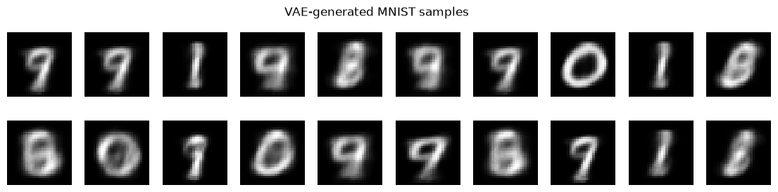

[Paste screenshot 3: VAE total, reconstruction and KL loss curves.]

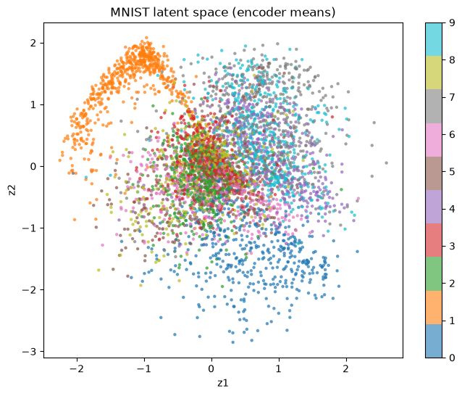

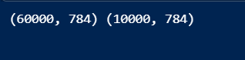

Observation
Record the training duration and final losses. Describe whether reconstructed digits remain recognizable, whether generated samples resemble handwritten digits and whether similar digit classes form visible groups in the latent plot. Mention any blurry or ambiguous samples.
Conclusion
The VAE experiment demonstrates how an encoder learns a probabilistic latent representation and how a decoder reconstructs or generates images from that representation. After execution, include the observed loss trend, reconstruction quality and latent-space behaviour. The experiment uses MNIST as specified by the handout.

